# Noise Invader v2.0

Designed by Valdemar Erlingsson

[www.analogwindow.com](http://www.analogwindow.com)

## Installation

Installation is done by simply copying the NoiseInvader2.dll file into your VST directory.

## Parameters

**Detection**

Controls which input is used for volume detection and controls the gain. By default, the left channel of the main input is used (“Main Left”), but this can be switched over to “Aux Left”. This allows you to place the noise gate after the gain stages, while using the direct guitar input as a control signal.

**Sensitivity**

Adjusts the gain of the detection input by +-20dB.

**Reduction**

Sets the maximum gain reduction that the effect will apply. Values of 40-80dB are usually appropriate if the effect is placed before the gain stage, 20-40dB if placed after.

**Threshold**

The signal level at which the gate turns on. If the input signal is above the threshold value, no gain reduction is applied.

**Slope**

Controls the slope of the expansion curve. Setting this to a low value (1.5-3) will give a smoother release while providing slightly less noise reduction just below the threshold point, while a high value will produce a sharp cut-off immediately after the signal goes below the threshold, acting more like a classic noise gate.

**Release**

Controls how quickly the signal fades out when the gate closes. Set to a low value for a sharp, dry sound. Set to moderate or high level for a less processed, “wetter” sound. This parameter can also be used to compensate if you get “chatter” while the note is decaying, it will prevent the gate from closing too quickly and then re-opening.

## Set-up

## In front of amplifier

Applying the noise reduction before the amp is a simple and usually effective way of reducing noise. However, some amplifiers “compress” the sound heavily, and this compression will also be applied to the noise reduction, which may result in a more abrupt cut-off around the threshold point than you might want. Also, if you are using the plugin with a hardware preamplifier, the hardware itself may be a source of noise, making this method less effective.

For most virtual/ampsim setups, this will work just fine.

## After the amplifier / In the FX Loop

Use this setup if you want a more transparent noise reduction that does not affect the amplifier/ampsim in any way. It is more complicated to set up, but can give better results, especially when using a hardware preamplifier in an FX loop.

## Reaper – In front of amp

1. Create a new track
2. Select your input, enable recording and monitoring

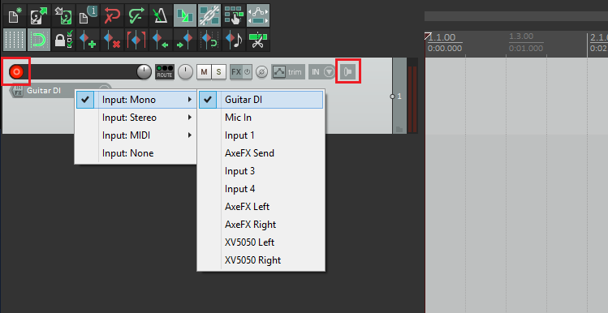

1. Set up your FX chain as you normally would, and then place NoiseInvader at the **start** of the chain

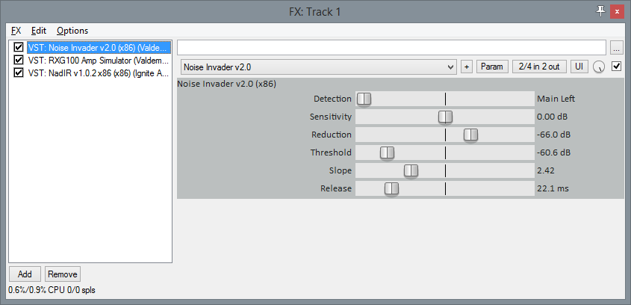

1. Adjust set the Reduction all the way to the right to start, and adjust threshold and Slope until you get a decent sound. If you’re unable to dial in a good response, try changing the Sensitivity to increase or decrease the detection gain.
2. Once you have the threshold, slope and sensitivity set, roll the Reduction as far left as it will go without the noise re-appearing. This ensures the plugin will apply just the right amount of gain reduction. Applying too much reduction can negatively affect the pick response.

## Reaper – In the FX Loop

1. Create a new track (it is a good idea to give it a descriptive name as well)
2. Select your input, then enable recording and monitoring



1. Set up your FX chain as you normally would and then place Noise Invader **after your ampsim/gain plugin**.

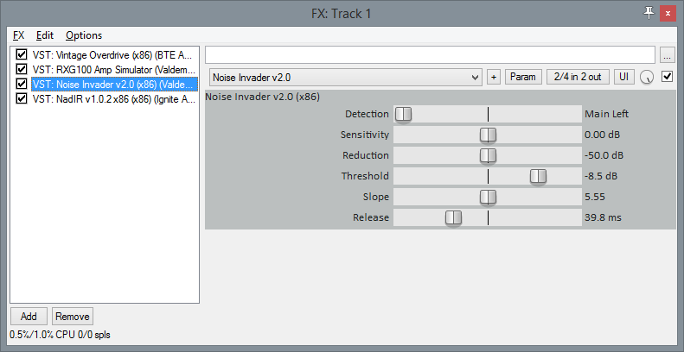

1. Click the Plugin Connector button to open the plugin router, then click the “+” button to add another set of inputs to this plugin

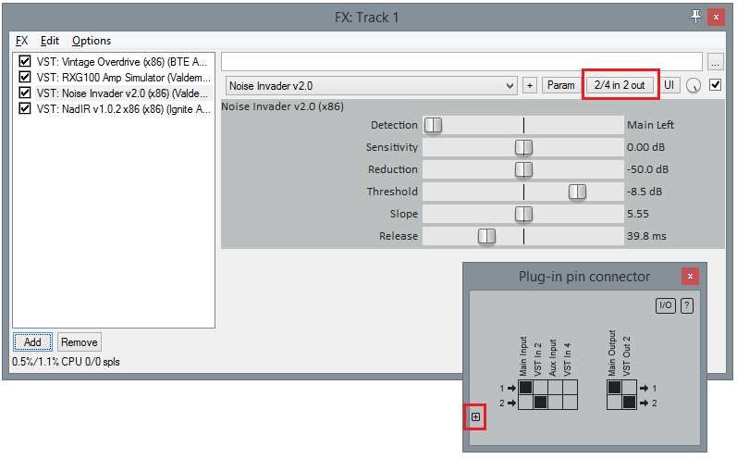

1. Repeat steps 1 and 2 so you have another track with your guitar as input
2. Open the Routing window for your new channel, unclick the Master Send checkbox, and select your main channel as a Send

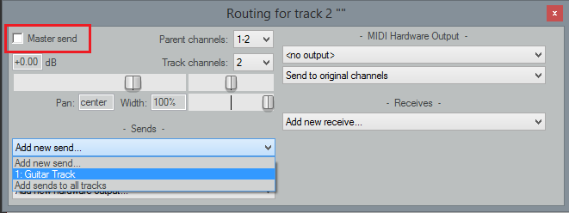

1. Set the input channel to 3/4 by adding a new set of channels to the Send track

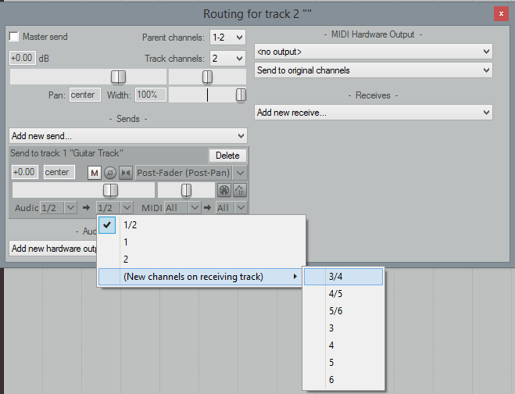

1. Finally, go back to Noise Invader and configure it to use the Aux Input. Adjust the settings like in the previous example

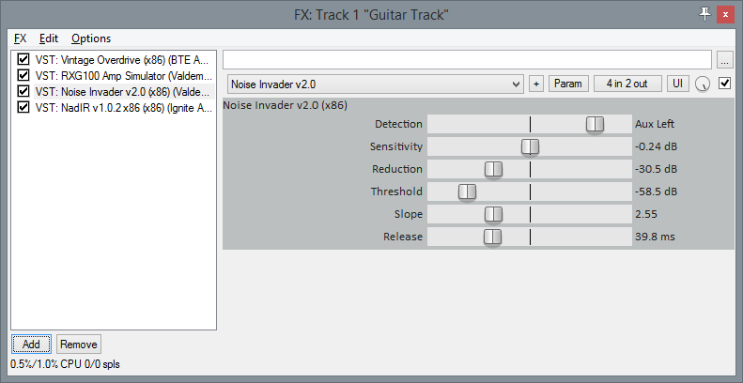

## Ableton Live – In front of Amp

1. Create a new Audio Channel, select your input, set Monitor to Auto/In and arm Record

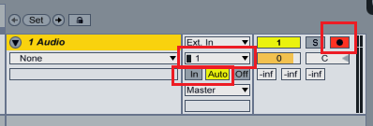

1. Set up your FX chain as you normally would, and then place Noise Invader at the **start** of the chain

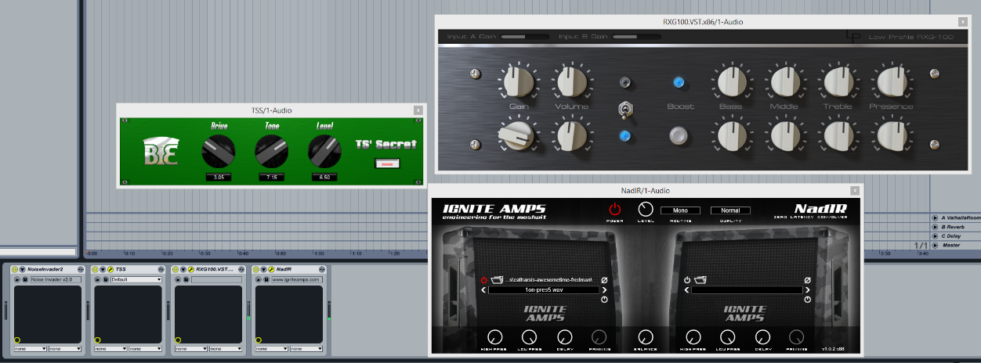

1. Adjust set the Reduction all the way to the right to start, and adjust threshold and Slope until you get a decent sound. If you’re unable to dial in a good response, try changing the Sensitivity to increase or decrease the detection gain.
2. Once you have the threshold, slope and sensitivity set, roll the Reduction as far left as it will go without the noise re-appearing. This ensures the plugin will apply just the right amount of gain reduction. Applying too much reduction can negatively affect the pick response.

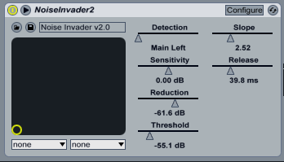

## Ableton Live – in the FX Loop

1. Create a new Audio Channel, select your input, set Monitor to Auto/In and arm Record (it is a good idea to give it a descriptive name as well)



1. Set up your FX chain as you normally would, and then place Noise Invader **after your ampsim/gain plugin**

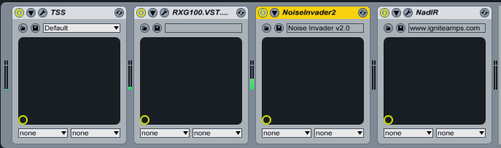

1. Create another track, select your input, set Monitor to “In”, do **not** arm the record (the original channel should still be armed)
2. In the channel settings, instead of “Master”, select the other track, and choose Aux Input - NoiseInvader2 as the destination

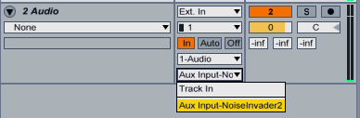

1. Finally, go back to Noise Invader and configure it to use the Aux Input. Adjust the settings like in the previous example

